PROJECT REPORT

BLOODLINK
BLOOD DONOR & BLOOD BANK MANAGEMENT PLATFORM

A Full-Stack MERN Web Application

Submitted by
SR.Abinaya  [kalasalingam academy of research and education]  (2026-2027)  (CSE. Dept) | S.Akhil  [kalasalingam academy of research and education]  (2026-2027)  (CSE. Dept)
K.Niranjan  [kalasalingam academy of research and education]  (2026-2027)  (CSE. Dept) | Harini  [kalasalingam academy of research and education]  (2026-2027)  (CSE. Dept)

ABSTRACT
BloodLink is a web-based Blood Donor and Blood Bank Management Platform developed to support the coordination of blood donation and blood availability during medical emergencies. The application provides a common digital platform for blood donors, blood banks, patients or hospitals, and administrators. It is designed to reduce the effort involved in locating suitable donors, communicating urgent requirements, and maintaining blood inventory information.
The system follows a multi-role approach. Donors can create and maintain profiles, update their availability, submit blood requests, and review request history. Blood banks can register their facilities, manage inventory for the eight major blood groups, and approve or reject incoming requests. Administrators can monitor platform activity through analytics and manage user, donor, blood bank, and request records.
BloodLink is implemented using the MERN stack: MongoDB, Express.js, React.js, and Node.js. The frontend is deployed at the provided Render URL, while the source code is available in the supplied GitHub repository. The platform aims to improve information accessibility, simplify request handling, and support faster coordination among stakeholders. The accuracy of inventory and donor availability depends on timely updates by registered users and participating blood banks.

1. INTRODUCTION
Blood is an essential resource in emergency treatment, surgeries, accident care, and several medical procedures. In urgent situations, patients and hospitals may need to identify compatible blood donors or locate a blood bank with available stock within a limited time. When information is scattered across phone calls, paper records, messaging groups, or independent databases, finding reliable and up-to-date information can become difficult.
BloodLink addresses this coordination problem through a centralized web application. It connects donors, blood banks, and requesters through role-based access and structured workflows. Users can access the platform through a web browser, while administrators can oversee records and activity. The system is intended as an information and request-management platform; actual blood collection, testing, compatibility verification, and transfusion decisions remain the responsibility of authorized medical professionals and blood-bank personnel.

2. OBJECTIVES
- To provide a centralized platform connecting blood donors, blood banks, and patients or hospitals.
- To allow donors to register, maintain profile information, and update their donation availability.
- To support submission and tracking of urgent blood requests using structured details.
- To enable blood banks to maintain blood-group-wise inventory information.
- To provide blood banks with request review actions, including approval and rejection.
- To provide administrators with tools for monitoring platform activity and managing records.
- To improve the accessibility and organization of blood donation and blood availability information.

3. EXISTING SYSTEM
In a conventional process, patients or hospital staff may contact multiple donors, hospitals, or blood banks individually to identify available blood. Information may be maintained in registers, spreadsheets, phone contacts, or separate online groups. These approaches can work in small networks but may become difficult to coordinate during time-sensitive situations.

Limitations of the Existing System
- Donor and blood-stock information may be distributed across multiple sources.
- Availability details can become outdated when donors or blood banks do not update records.
- Manual communication may increase the time required to identify a possible source.
- Request status may be difficult to track consistently across calls and messages.
- Maintaining and reviewing records manually can create administrative overhead.
- Centralized monitoring and reporting may be limited.
These limitations describe common challenges in manual or disconnected workflows. They should not be interpreted as a claim that every existing blood-bank system has these shortcomings.

4. PROPOSED SYSTEM
BloodLink proposes a centralized, role-based web platform for managing donor information, blood-bank inventory, and blood requests. Each user category is provided with functions relevant to its responsibilities. The application organizes information in a structured database and presents it through a browser-based interface.

Major Features
- Donor management: donor registration, profile maintenance, availability status, urgent request submission, and request-history tracking.
- Blood-bank management: facility registration, inventory management for A+, A-, B+, B-, AB+, AB-, O+, and O-, and request approval or rejection.
- Request management: capture of blood group, hospital, city, required units, and reason, with status information such as pending and approved; additional status labels are shown according to the implemented workflow.
- Administrator management: dashboard analytics, searching and filtering records, managing users, viewing donor and blood-bank directories, and inspecting requests.
- Role-based access: user-facing functions are organized according to donor, blood-bank, and administrator roles.
The platform supports information sharing and workflow coordination. It does not itself certify donors, perform medical compatibility checks, reserve or physically issue blood, or replace statutory blood-bank procedures.

5. TECHNOLOGIES USED
- MongoDB: A NoSQL document database used to store application data such as user profiles, blood-bank information, inventory records, and requests, subject to the repository's implemented schemas.
- Express.js: A Node.js web application framework used to build server-side routes and APIs.
- React.js: A JavaScript library used to build the interactive, component-based frontend.
- Node.js: A JavaScript runtime used to execute server-side application code.
- HTML5 and CSS3: Used for page structure, layout, styling, and responsive presentation.
- JavaScript: Used for frontend and backend application logic.
- Render: The supplied live frontend URL is hosted on Render.
- Git and GitHub: Used for source-code version control and repository hosting.

6. HARDWARE AND SOFTWARE REQUIREMENTS

6.1 Hardware Requirements
- Computer or laptop with a modern 64-bit processor.
- Minimum 4 GB RAM; 8 GB RAM or higher is recommended for development.
- At least 2 GB of available storage for project files and development tools.
- Stable internet connection for accessing the deployed application and cloud services.
- Display, keyboard, and mouse or touchpad.

6.2 Software Requirements
- Operating system: Windows, Linux, or macOS.
- Modern web browser such as Google Chrome, Microsoft Edge, or Mozilla Firefox.
- Node.js (v18 or higher recommended) and npm for local development and dependency management.
- Visual Studio Code or another source-code editor.
- MongoDB Atlas cluster and Mongoose for database connectivity and schema modelling.
- Git for version control and access to the GitHub source repository.
- Render hosting account/service for the deployed web application.
Note: These are practical baseline requirements for accessing or developing a MERN application. Exact versions, environment variables, database configuration, and deployment settings should be confirmed from the project's package files and deployment configuration.

7. SYSTEM DESIGN / ARCHITECTURE
BloodLink follows a client-server architecture based on the MERN stack. The React 19 frontend, built with Vite and React Router v7, communicates with the Node.js and Express.js 5 backend through RESTful APIs. Axios is used by the client for API communication and attaches a Bearer token through an interceptor. The backend uses JWT-based authentication, bcryptjs for password hashing, and Mongoose models to interact with MongoDB Atlas.

7.1 High-Level Architecture
Users: Donor | Blood Bank | Administrator
↓
React.js Frontend (User Interface)
↓ HTTP / API Requests
Node.js + Express.js 5 Backend (REST APIs, Controllers, JWT Middleware)
↓ Database Operations
MongoDB Atlas (Mongoose Models)
Figure 1. Conceptual architecture of the BloodLink MERN application.

7.2 Data Flow
- A user opens the BloodLink website and accesses the functions available for their role.
- The React frontend collects user input and sends the relevant request to the backend API.
- The Express.js server receives the request and executes the corresponding application logic.
- The backend interacts with MongoDB to retrieve, create, or update records.
- The server returns a response to the frontend, which updates the interface and displays the result.

8. MODULES DESCRIPTION

8.1 Donor Module
Allows donors to register and maintain profiles, update phone number, city, and state, toggle availability, appear in donor searches filtered by blood group and city, submit urgent requests, and track or cancel their pending requests.

8.2 Blood Bank Module
Allows blood banks to register facility details, manage stock units for all eight blood groups, filter incoming requests by blood group, status, or city, and approve, reject, or mark requests as fulfilled. Approved requests can show the handling blood bank's contact name, city, and phone number to the requester.

8.3 Blood Request Module
Captures blood group, hospital name, city, required units, and medical reason. The application validates the eight supported blood groups and displays request statuses: pending, approved, fulfilled, rejected, and cancelled. Requesters can cancel pending requests.

8.4 Administrator Module
Provides platform analytics for total users, donors, blood banks, total requests, pending requests, and fulfilled units. Administrators can search users by name or email, filter by role, delete accounts, view donor and blood-bank directories, and inspect requests across the platform.

8.5 Authentication and Role Management
Supports donor, blood-bank, and administrator roles. The repository documents JWT-based authentication, bcryptjs password hashing, JWT verification middleware, and administrator privilege middleware.

9. WEBSITE SCREENSHOTS
Screenshot placeholders are provided below. The live site could be opened, but its page content was not available as readable text in the inspection view; therefore, no screenshots have been fabricated. Insert screenshots captured directly from the deployed BloodLink website before final submission.
[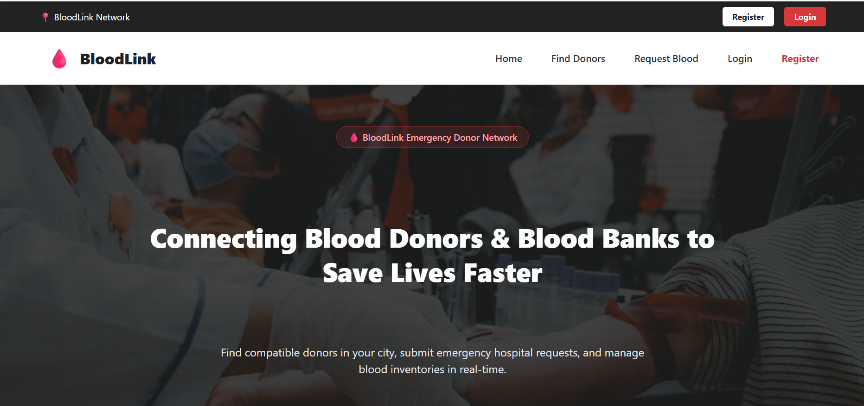
Figure 1. Home page / landing page
[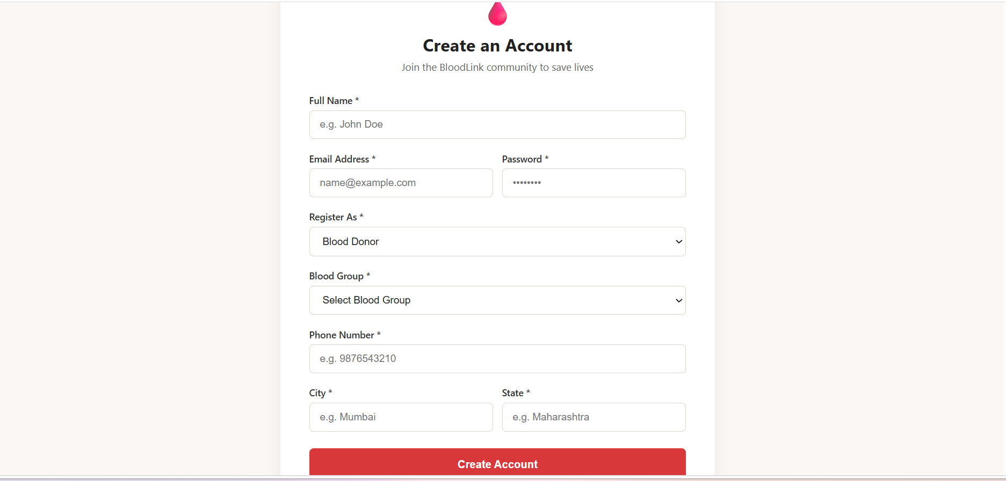
Figure 2. Donor registration and profile
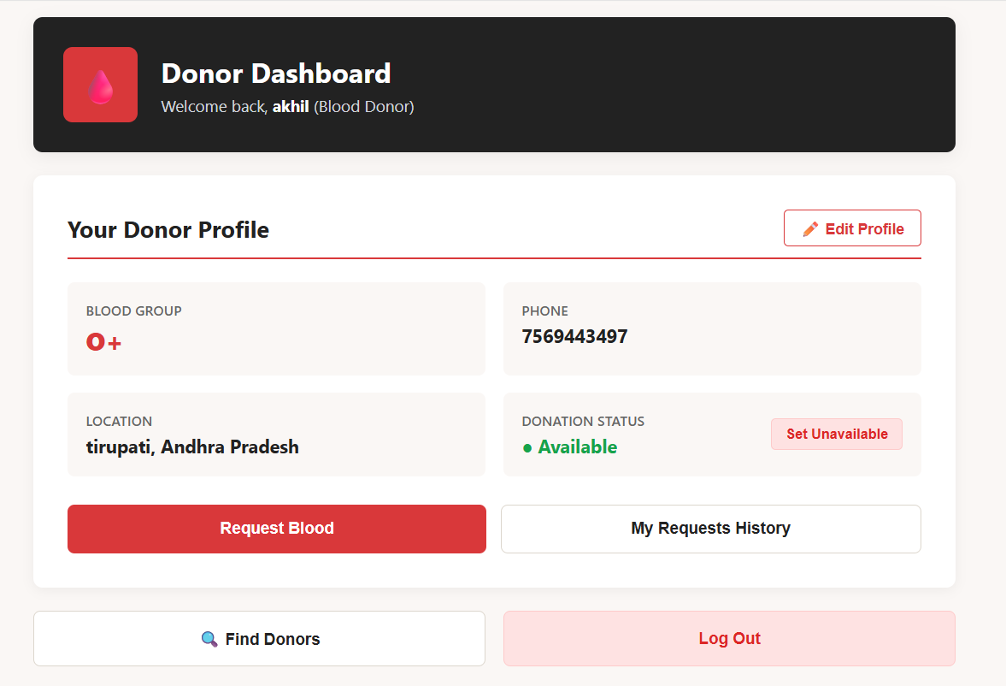Figure 3. Blood request form
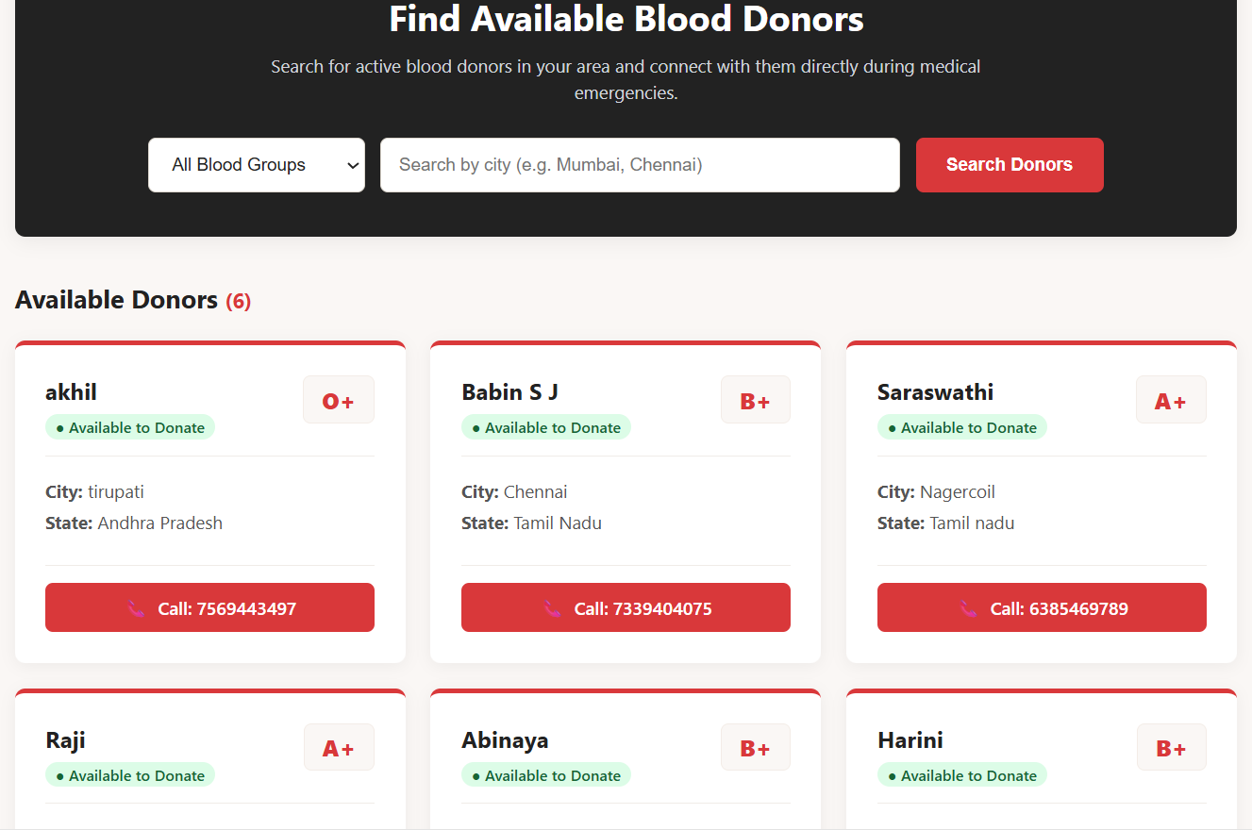Figure . Blood bank inventory dashboard

10. CONCLUSION
BloodLink demonstrates how a full-stack web application can organize donor information, blood-bank inventory, and blood-request workflows within a common platform. By providing separate functions for donors, blood banks, and administrators, the system supports more structured communication and record management. The MERN stack provides a JavaScript-based architecture across the frontend and backend, while MongoDB supports storage of application data.
The project can be enhanced further by integrating verified blood-bank data, location-based donor discovery, secure notifications, stronger audit trails, analytics, and improved accessibility. Any real-world deployment should include appropriate privacy safeguards, identity and facility verification, security testing, data-retention policies, and compliance with applicable medical and blood-bank regulations. BloodLink is intended to assist coordination and must not replace professional medical judgement or authorized blood-bank processes.

11. REFERENCES
- BloodLink deployed frontend. https://bloodlink-frontend-44lx.onrender.com/ (accessed 12 November 2026).
- BloodLink source-code repository. GitHub. https://github.com/akhilshroff06-ship-it/Blood-Links (accessed 12 November 2026). Repository README and documented project structure/API summary consulted for implementation details.
- MongoDB Documentation. https://www.mongodb.com/docs/
- Express.js Documentation. https://expressjs.com/
- React Documentation. https://react.dev/
- Node.js Documentation. https://nodejs.org/docs/
- Render Documentation. https://render.com/docs

